Class provides a blueprint for the creation of object

In Javascript we can make objects out of classes by using new keyword

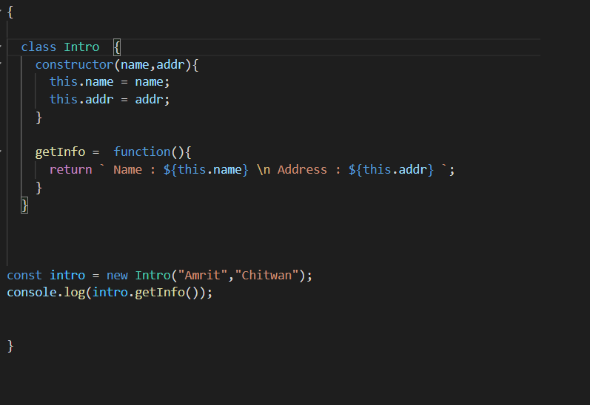

this is how we make a Class and object out of it in javascript

Few Rules

1. All the variables must be declared, initialized inside the constructor()
2. All the methods must be defined outside the constructor() method
3. A constructor() inside of class gets automatically called when the object of that class is created
4. While defining methods inside the class never use arrow function, always use regular function but it is optional to write function keyword

See below

Same class as above but methods are defined without function keyword

